**Ordinary differential equation (ODE) :** In mathematics, an ordinary differential equation (ODE) is a differential equation containing one or more functions of one independent variable and its derivatives. The term ordinary is used in contrast with the term partial differential equation which may be with respect to more than one independent variable

**Picard's Method: Numerical solution of Differential Equations**

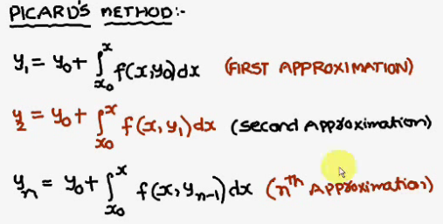

Example: Math

